|  |  |
| --- | --- |
|  | **DOKUZ EYLÜL UNIVERSITY**  **ENGINEERING FACULTY**  **DEPARTMENT OF COMPUTER ENGINEERING** |

<VURKAC MS>

# CME 3201 Database Management Systems

# Term Project Report

Phase 3

2020-2021 FALL

|  |  |  |
| --- | --- | --- |
| 2017510053 | Süleyman Ayberk Kılıçaslan | suleyman.kilicaslan@ceng |
| 2017510090 | Hazar Özyağcı | hazar.ozyagci@ceng |
| 2017510063 | Arif Mertaslan | arif.mertaslan@ceng |

**Abstract**

The planned cinema management system was completed with all its functions. This management system has been completed in order to contribute to safe and fast transactions in the cinema sector. Thanks to the system, movie theater managers will have a website where they can store and manage their data, while customers will be able to book movie theaters and movies registered in the system at the same time.

In this system, PHP Codeigniter is used as backend, HTML and CSS are used as frontend and implementation was done using model-view-controller design pattern. Database operations performed on phpmyadmin using MySQL.

## Completion Report

All of the functions on the figure 1 that specified in phase 1 have been completed. Depending on the functions completed, the admin will be able to view movies and sessions and edit them or add new ones. Also, admin has the authority to delete users.

The user will also be able to sign up and log in, view the movie theaters and movies registered to the system, and reserve the appropriate seats in the movie theater and the movie he/she wants, if he/she logs in.

There was no problem in completing the milestones on the figure 2 that specified in phase 1, as we initially planned correctly. There were only minor changes in the milestones due to some changes we made regarding the tasks to be done.

|  |  |
| --- | --- |
| 1 | User registration (Customer) |
| 2 | User login (Customer/Admin) |
| 3 | Check seat statement and sessions (Customer/Admin) |
| 4 | Reserve a ticket (Customer) |
| 5 | Add/Remove movies (Admin) |
| 6 | Update sessions and movies (Admin) |
| 7 | Rate the movie (Customer) |
| 8 | Delete Customer (Admin) |

Figure 1: Functionality

|  |  |
| --- | --- |
| Database Designing | One Week |
| Frontend Part 1 | Two or Three Weeks |
| Backend Part and Frontend Part 2 | Two or Three Weeks |
| Testing and Polish-Release | One or Two Weeks |

Figure 2: Milestone and Timeline

## Functional Decomposition

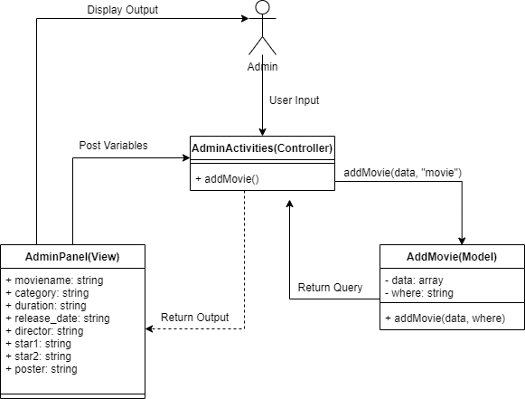

Figure 3: Add Movie Function

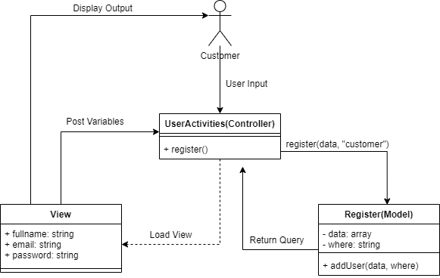

Figure 4: Sign Up Function

## High Level Organization

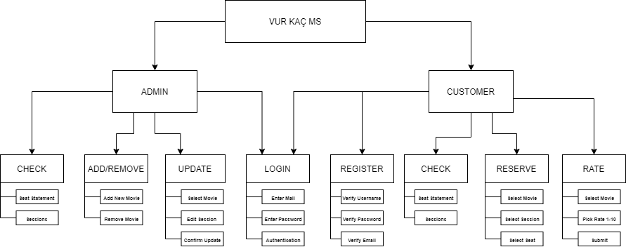

Figure 5: High Level Organization

## Clickstreams

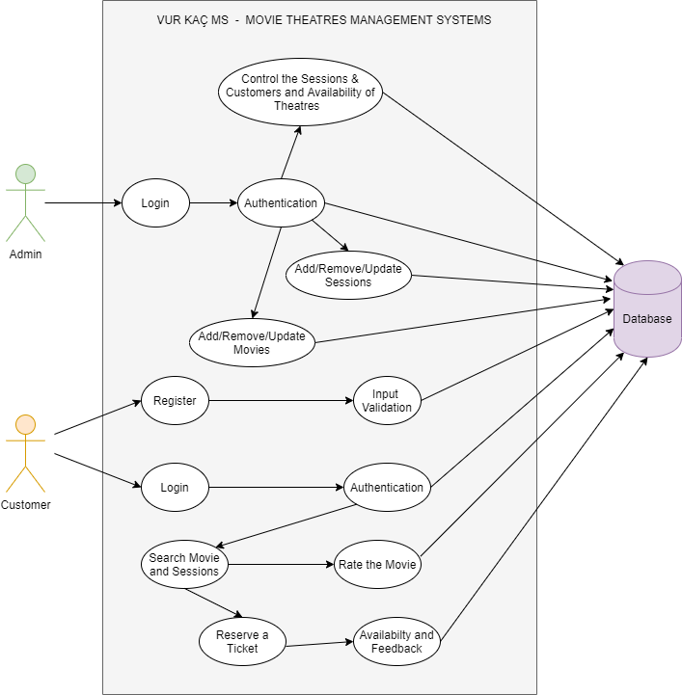

Figure 6: Use Case Diagram

## Layout

Wire Frame:

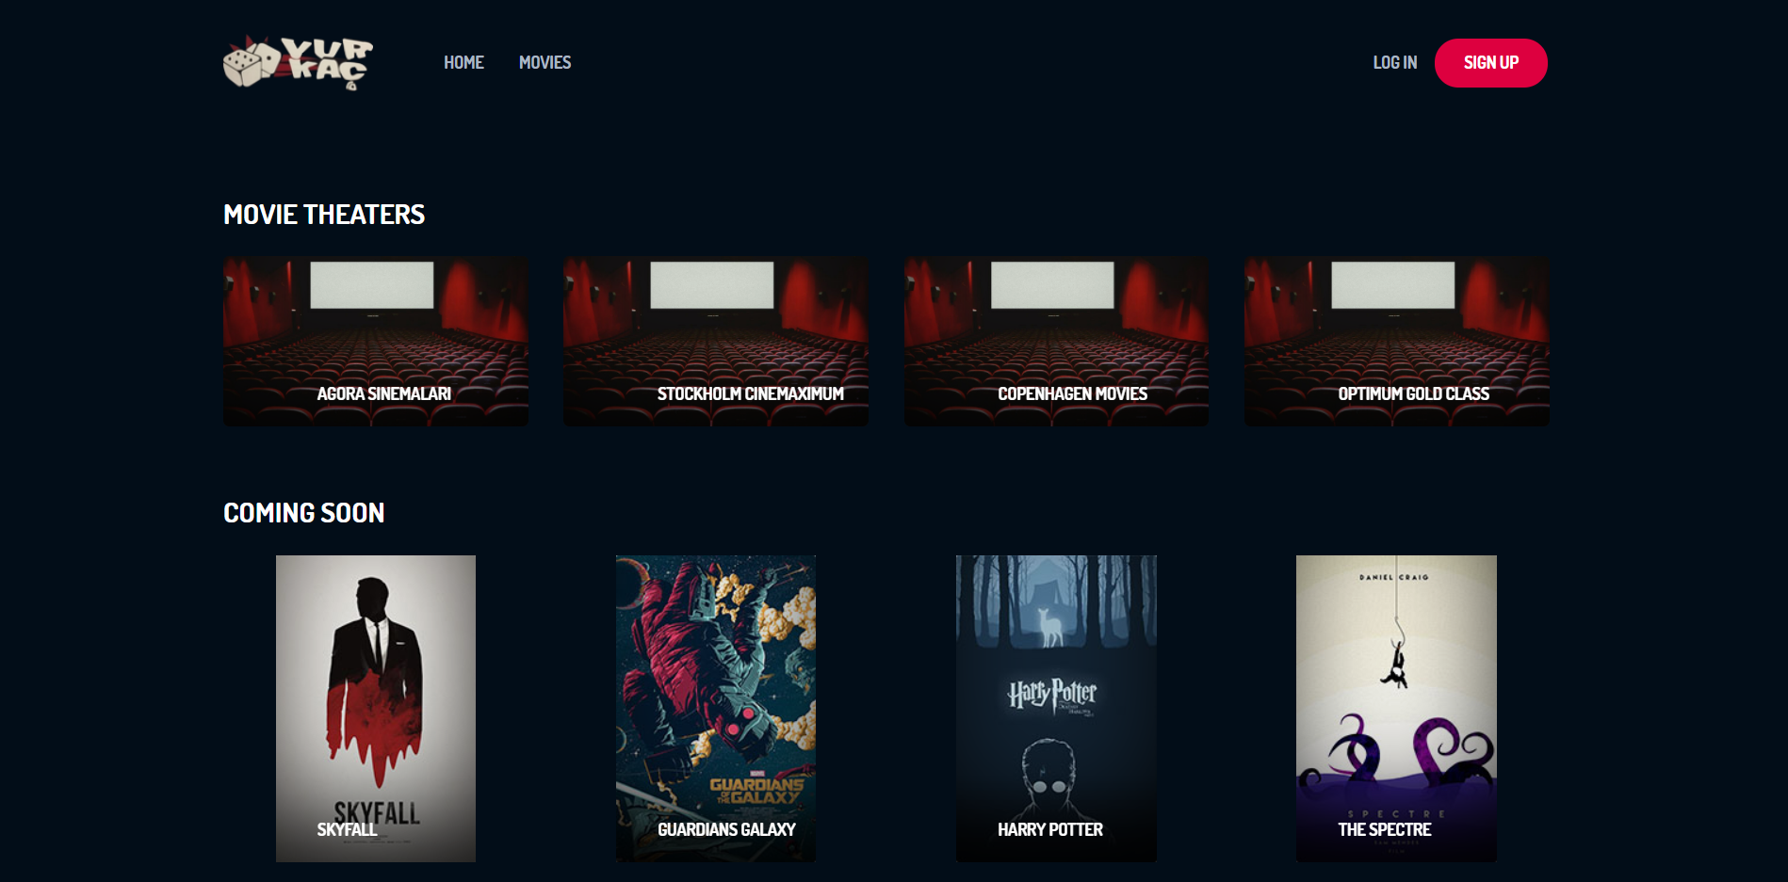

If user logged in as a customer in the login page, there will be movie theaters on the main page. There will be movies button which presents the movies as a list on the navbar. If user selects a movie from that list, new page will appear on the screen. User is able to rate the movie if user watched the movie already, if user has not watched it yet then, user can click the reserve button. After that, there will be a page which includes theatre selection, session selection and seat selection. Also, if user selects the theater on the main page, customer will see the same page. If the reserve progress complete, the ticket will be pop-up on the screen.

Admin Panel Wire Frame:

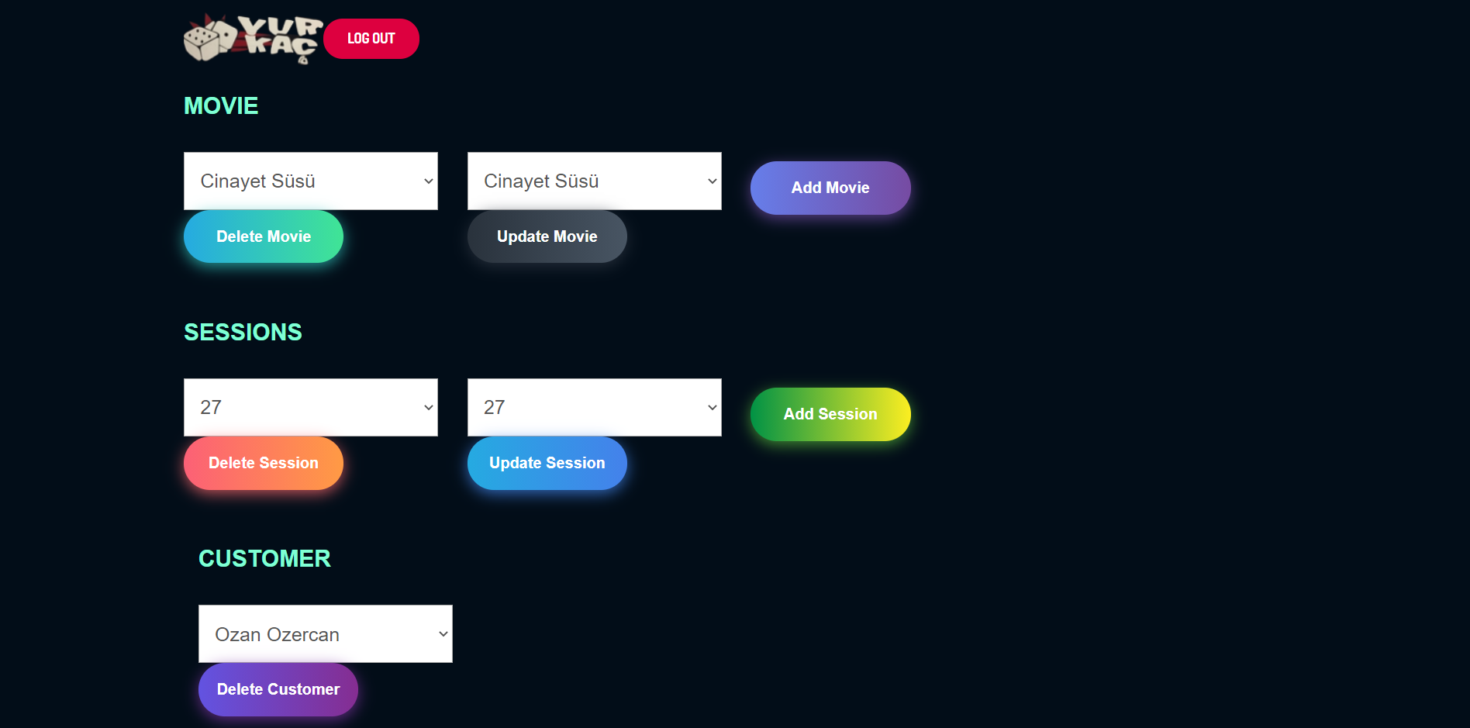

If user logged in as an admin, there will be a page which helps to manage whole system with basic designed page which includes list of theatre, room and movie. In this page, admin manages the system by inserting or removing movies and session.

## Implementation



If user clicks the login button:

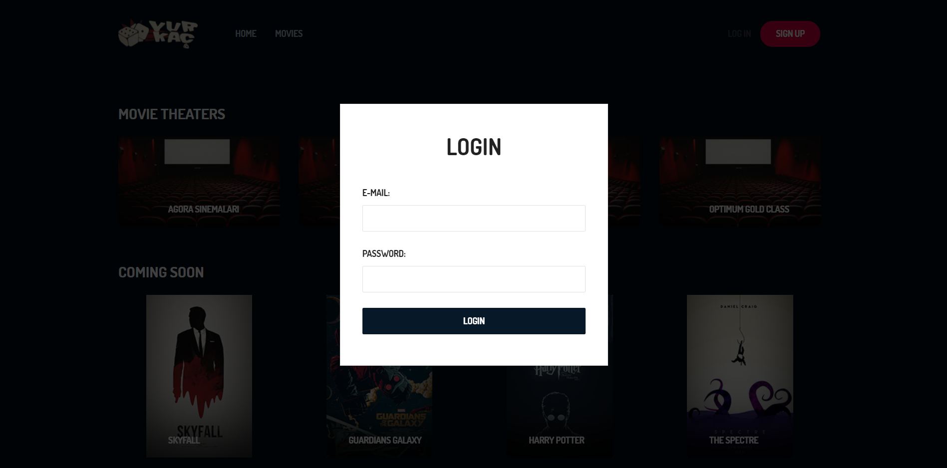

If user clicks the register button:

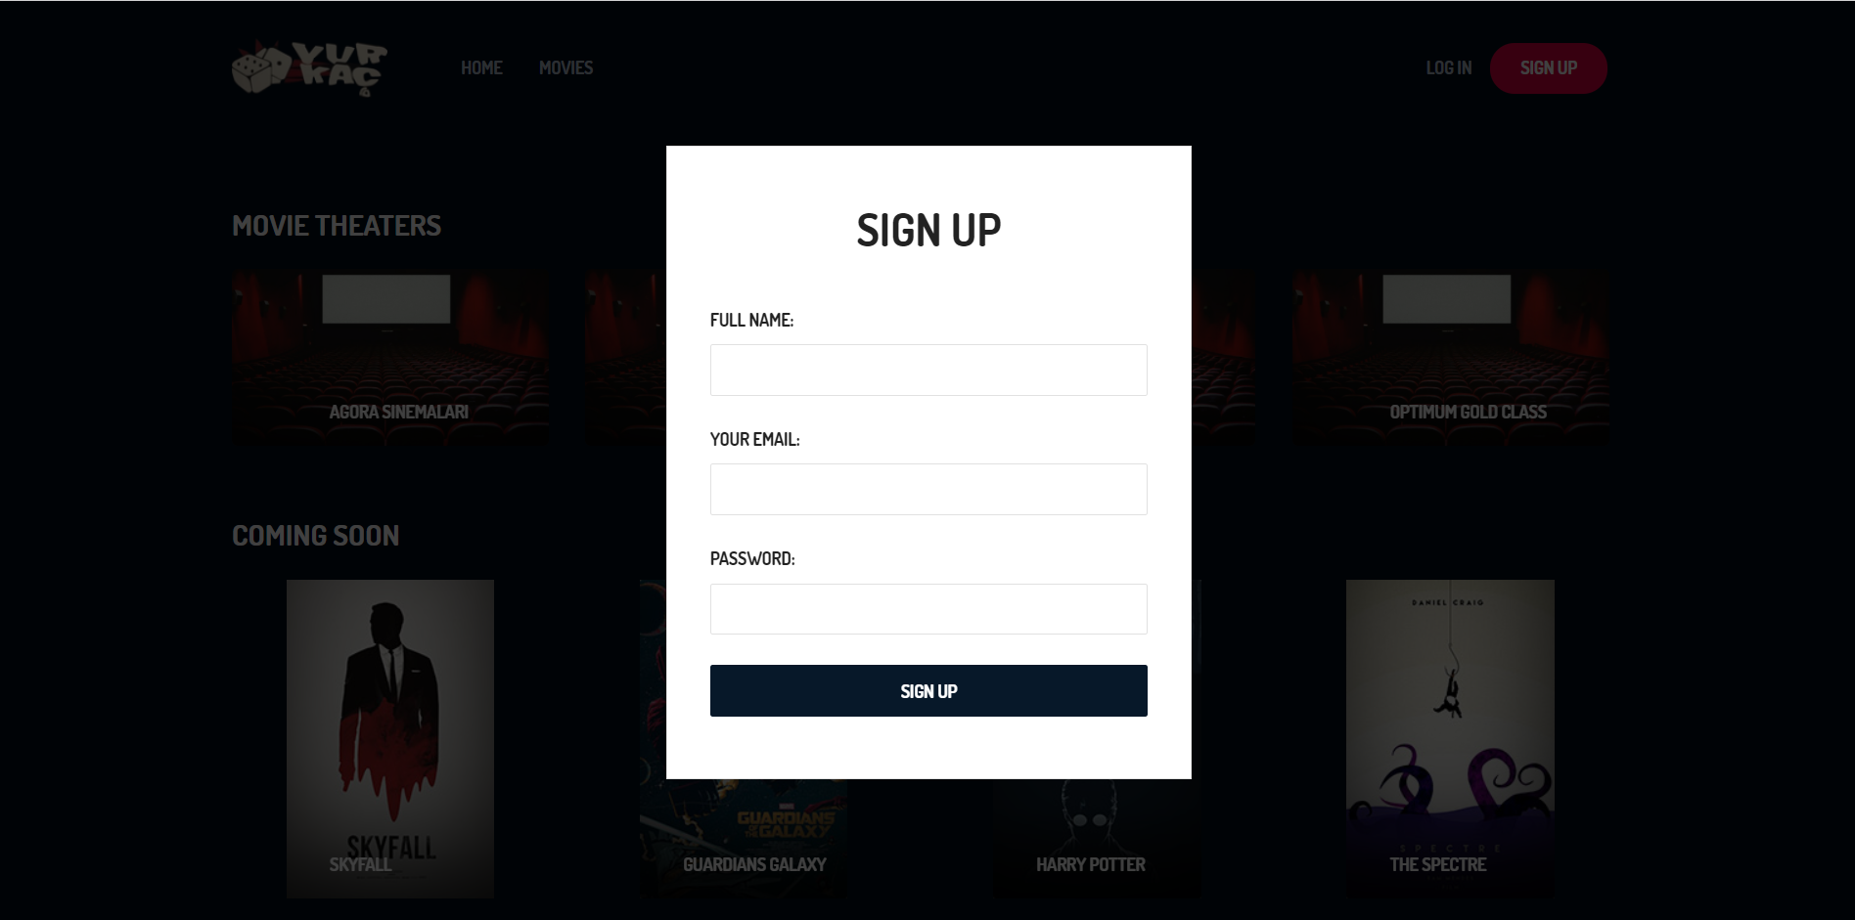

If user clicks the “movies” button, application will redirect user to another page which includes all movies from database:

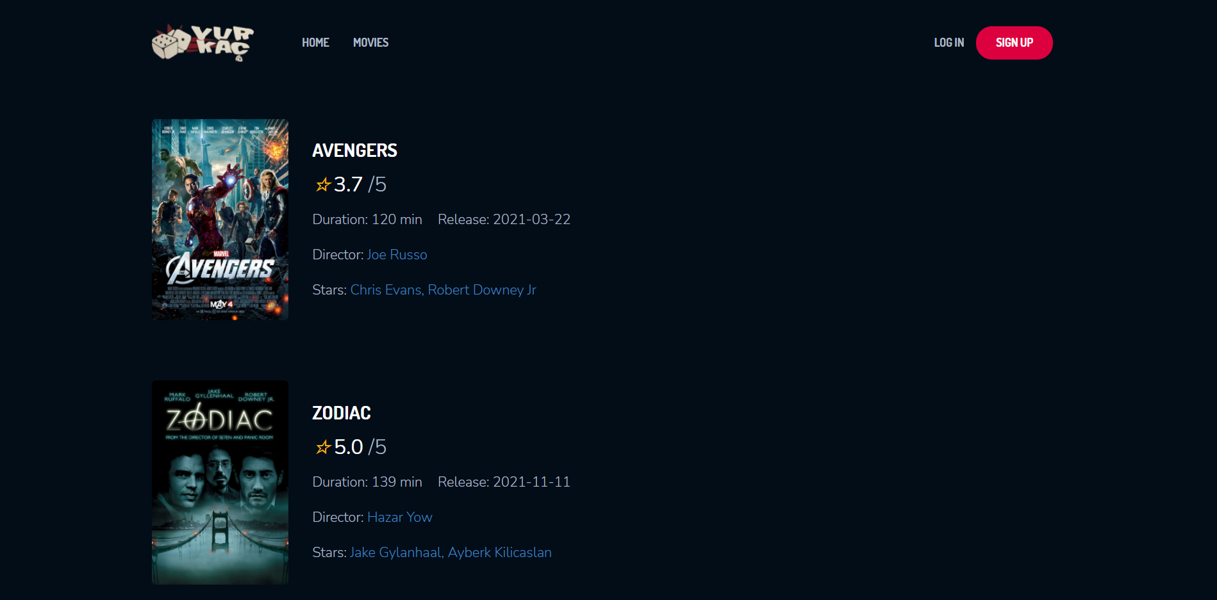

If user selects theater from main page, application will redirect user to another page which includes movies in that theater:

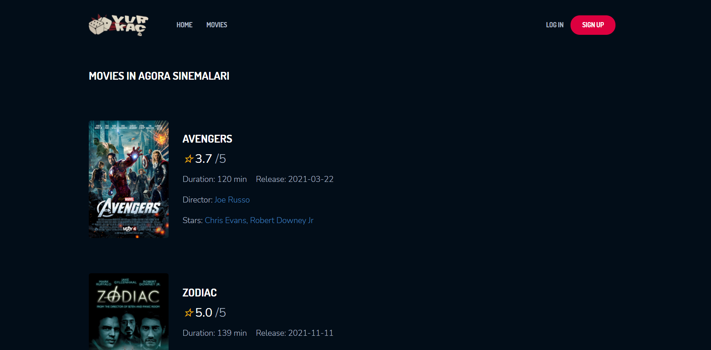

On these pages, user is able to select movie to rate or reserve ticket:

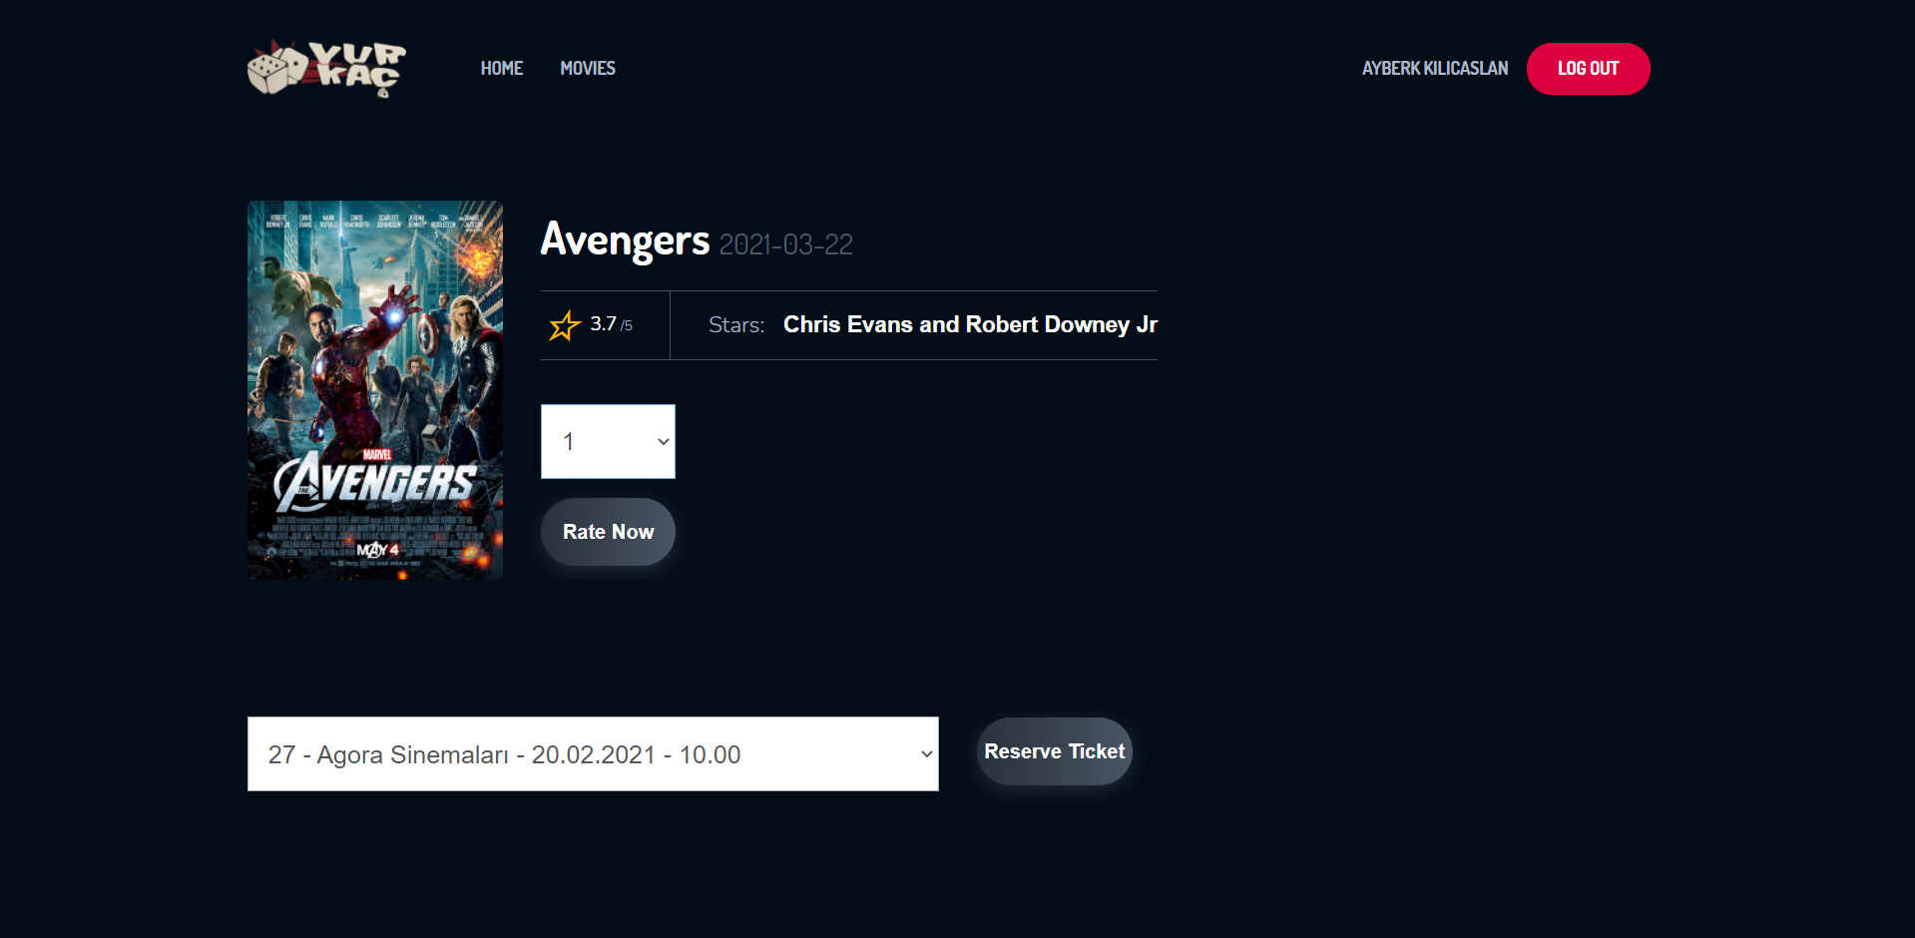

If user logged in already, on this page, user can rate the movie. If user wants to reserve a ticket, user has to selects session and clicks the “reserve ticket” button:

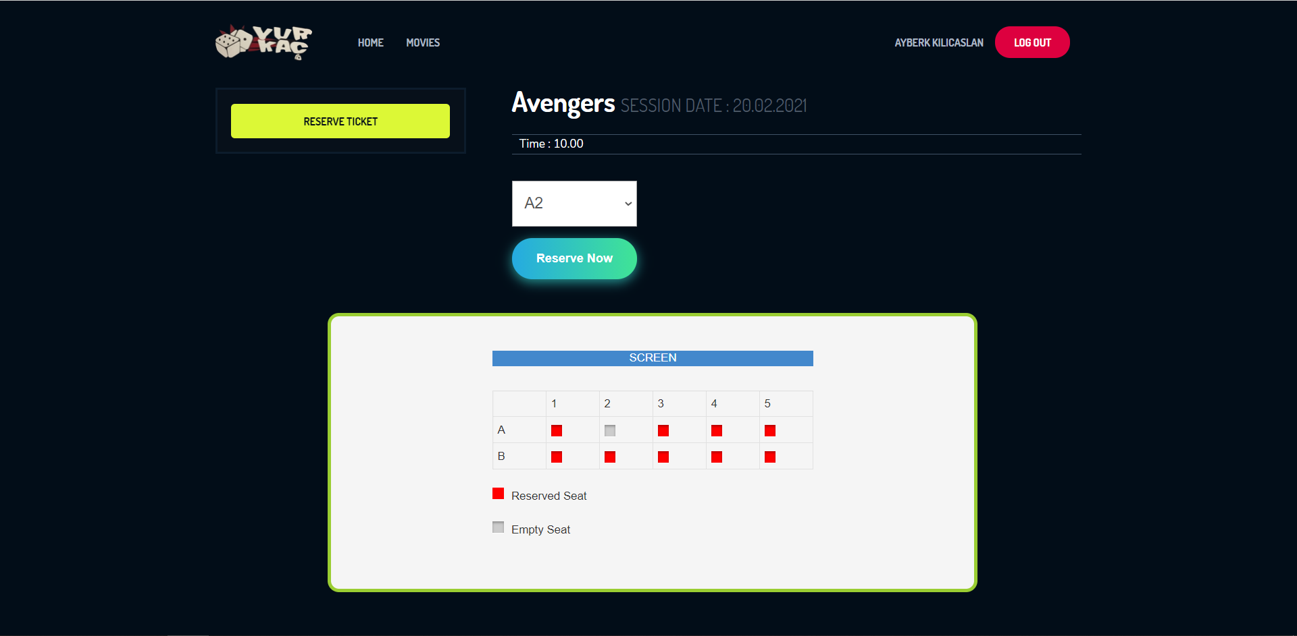

After the reserve statement finished, user’s ticket will show up on the page:

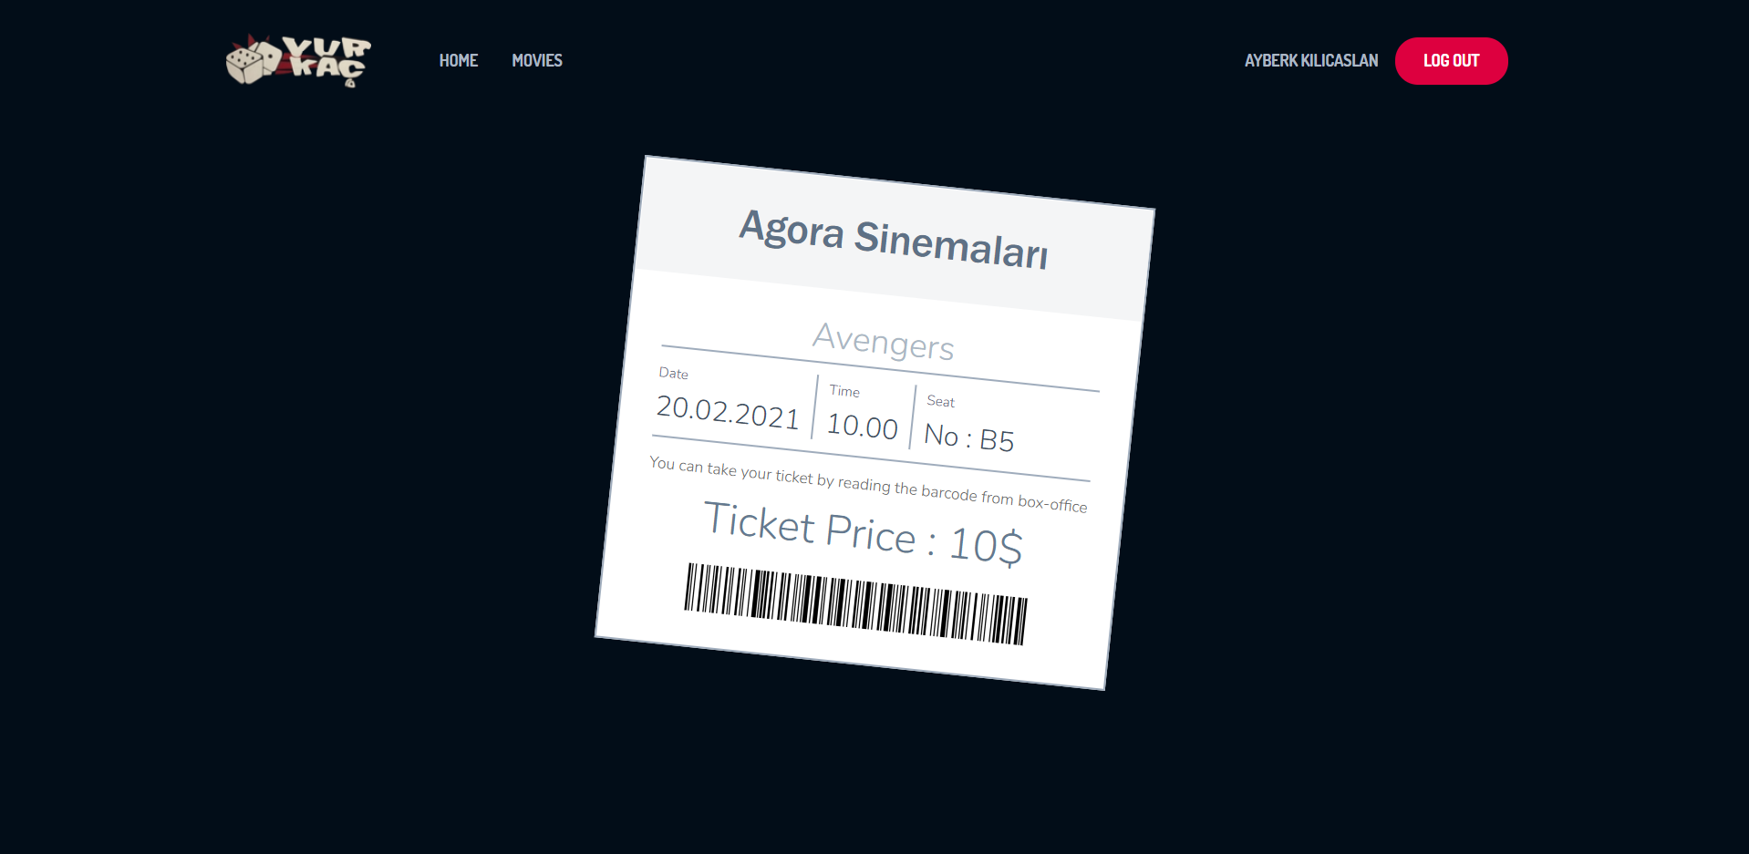

If admin wants to add movie/session popup will appear on the screen:

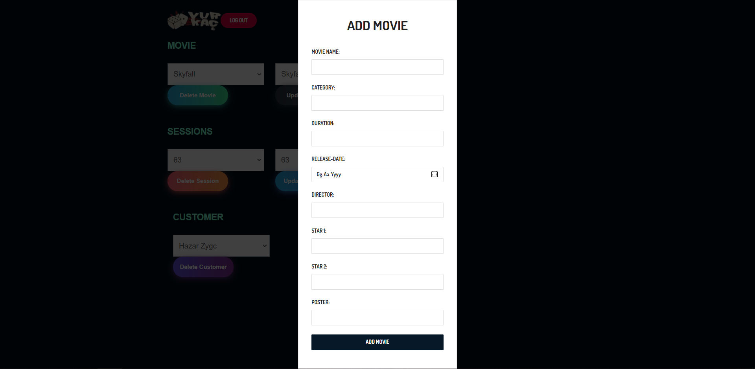

If admin wants to update movie/session another page will appear on the screen:

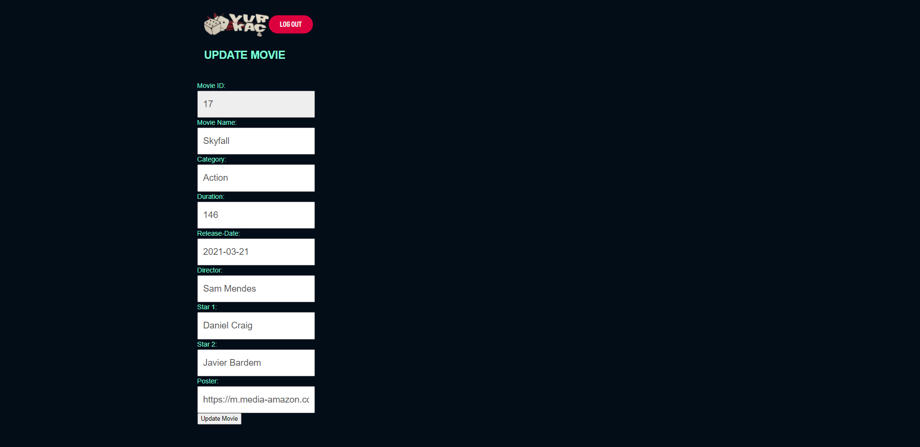

If admin wants to delete movie/session/customer, admin has to select and click the delete button.

## Future Work

All of the parts we planned in the project have been completed. Although there is no need to do anything extra for the backend part and the database, if we had more time, improvements could be made to the interface in the frontend part. For example, a list of options was presented to complete session and ticket display operations faster. If there was more time, those selection operations could also be created more functionally on a single page.